Budgeting for Beginners
A budget is the first step in taking control of your money. It shows your income and spending over a set period of time, usually a month. This can help you plan your spending, manage your money and set savings goals. However, it can be a daunting process. StepChange’s top tips can help you learn to budget like a pro.
A budget can also help you avoid getting into debt (or help you get out of debt), plan for big one-off purchases or spot chances to save money. It’s also really useful if your income fluctuates as it can help to smooth out any ‘peaks and troughs’ in your income.

1. Get your financial information together
You’ll need to gather details of your:
- Regular household bills (utilities, phone etc)
- Living costs (food, toiletries, prescriptions, clothing)
- Insurance policies
- Travel expenses (petrol, MOT, parking, bus)
- Leisure (gym, cinema trips)
- Debt repayments (loans, credit cards)

Don’t worry if you don’t have these figures to hand. You should be able to find these by looking at your bank statements or online banking accounts.

2. Your income
This includes any wages or salary, as well as any money from benefits, pensions, or any other money you have coming in.
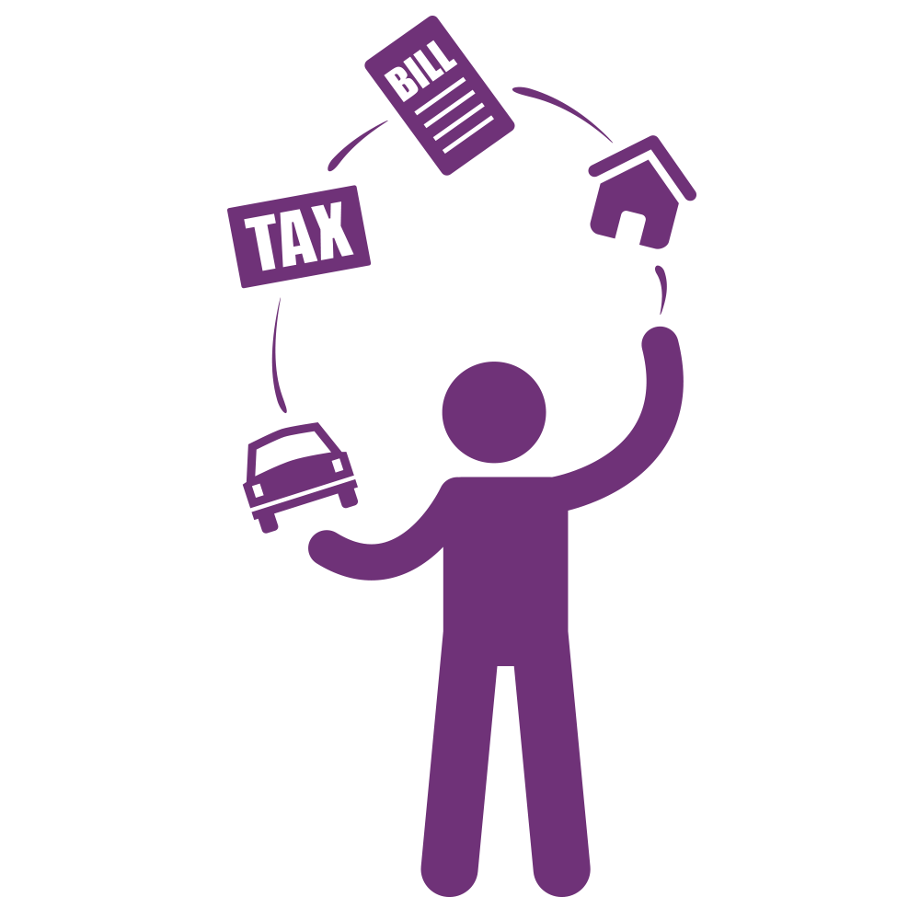
If you don’t work regular hours and your income can vary from month to month, take a look at StepChange's guide to budgeting on a fluctuating income.

3. Add up your regular spending
Work out what you spend every month in each of the following areas:
- Housing and household bills
- Travel costs
- Housekeeping, including food, cleaning, pets and clothing
- Children/family
- Leisure/entertainment
- Health and toiletries
- Any debt repayments or court payments
- Other living costs

This free budgeting sheet can help you with this.

4. Don’t forget one-off expenses
One of the aims of a budget is to help you plan your spending fully. Don’t forget to include one-off expenses, such as your car MOT, or home repairs. To do this, take the amount you’ll need for the expense, divide it by 12, and add this figure to your monthly budget. Then put this amount aside every month - putting it in a savings account can help you avoid dipping into it.

5. Do you have a ‘surplus’ or ‘deficit’ budget?
Once you’ve worked out your monthly income and taken away your outgoings, is there money left over?
If there is, this is a ‘surplus’. You should put this towards your debts if you have any – if not, save it! If your surplus is small, check your budget and see if there are areas where you can cut back your spending.
If you’re spending more than your total income each month you have what’s called a ‘deficit’, and could be at risk of getting into financial problems. If you’re using credit to pay for everyday living costs, or are often using your overdraft, you may want to consider getting debt help.

6. Open a savings account
If your budget allows, it’s a good idea to set up savings accounts to put any extra money aside.
It’s sensible to have one for planned one-off purchases, and another for an ‘emergency fund’. It can be tempting to dip into your savings, so a savings account with a different bank can help, as it’s not linked to your current account. Having some rainy day savings can help you avoid getting into debt if you have an income shock, such as redundancy or illness.

8. Look for ways to save
In almost every budget there are areas where you could save. Could you:
- Move to a cheaper phone tariff?
- Save on your TV package?
- Get a better deal on your insurance?
IsMyBillFair is an easy way to find out if you’re paying over the odds, and can help you to shop around and get a better deal.

9. Keep up to date
Once you’ve started to budget, review your spending regularly. This can be as often as you like, but it’s worth checking every few months:
- Has your income increased/decreased?
- Are there items in your budget you no longer need?
- Have any of your costs increased/decreased?
- Have your benefits entitlements changed?
- Does your budget match what you’re actually spending?
- If you’ve planned to build up any savings or pay off any debts - are you on target?

Now you understand the basics, set aside a couple of hours, make a cup of tea and get budgeting!

